Where was Abraham from?

Genesis 11:31
And Terah took Abram his son, and Lot the son of Haran his son's son, and Sarai his daughter in law, his son Abram's wife; and they went forth with them from Ur of the Chaldees, to go into the land of Canaan; and they came unto Haran, and dwelt there.

Abraham’s family moved from Ur of the Chaldees to Haran (in Syria/Padan-aram/Aram-naharaim).

Genesis 24:1-4
¹ And Abraham was old, and well stricken in age: and the LORD had blessed Abraham in all things.
² And Abraham said unto his eldest servant of his house, that ruled over all that he had, Put, I pray thee, thy hand under my thigh:
³ And I will make thee swear by the LORD, the God of heaven, and the God of the earth, that thou shalt not take a wife unto my son of the daughters of the Canaanites, among whom I dwell:
⁴ But thou shalt go unto my country, and to my kindred, and take a wife unto my son Isaac.

Genesis 24:10
And the servant took ten camels of the camels of his master, and departed; for all the goods of his master were in his hand: and he arose, and went to Mesopotamia, unto the city of Nahor.

When his son Isaac was of age, Abraham sent his servant back to Mesopotamia (Syria/Padan-aram/Aram-naharaim) to get him a wife from Abraham’s kindred (his brother Nahor’s son Bethuel had a daughter named Rebekah)(Gen 11:26, 22:22,23).

Genesis 25:20 (28:5)
And Isaac was forty years old when he took Rebekah to wife, the daughter of Bethuel the Syrian of Padanaram, the sister to Laban the Syrian.

Genesis 31:20,24
²⁰ And Jacob stole away unawares to Laban the Syrian, in that he told him not that he fled.
²⁴ And God came to Laban the Syrian in a dream by night, and said unto him, Take heed that thou speak not to Jacob either good or bad.

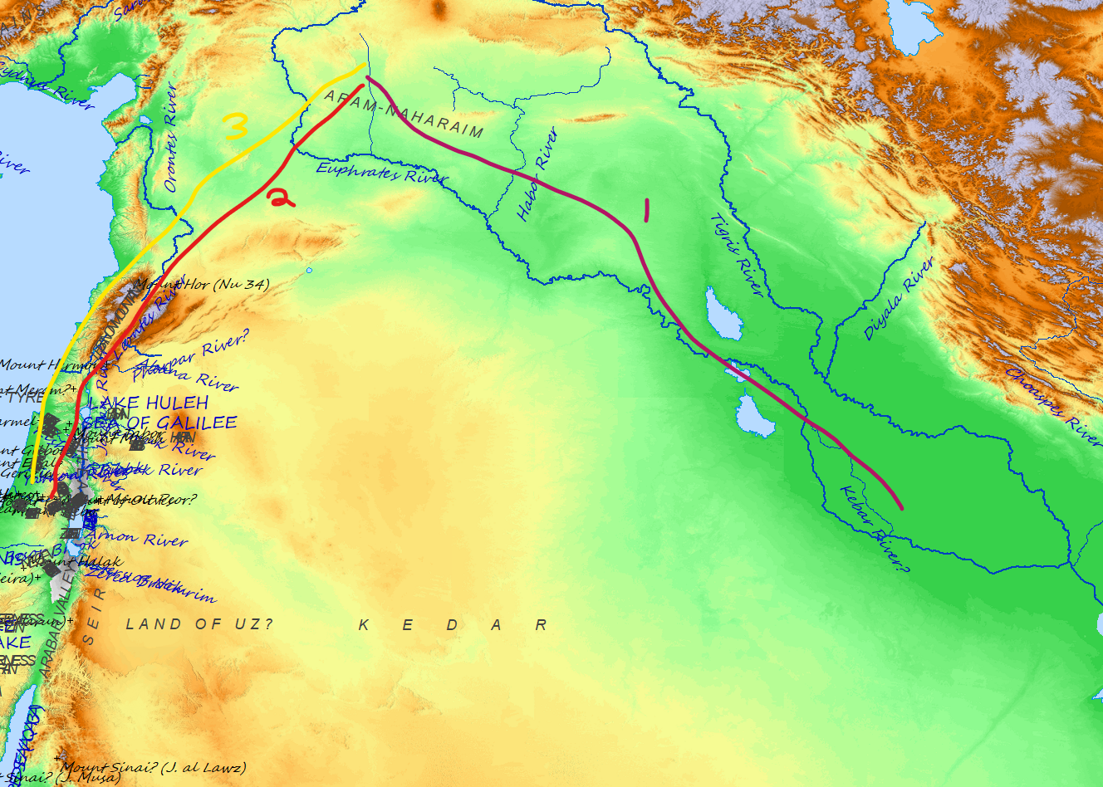

- Abraham’s family travels to Haran and settles there.
- Abraham moves on to Canaan.
- Abraham sents his servant to get a wife for his son Isaac from his brother Nahor’s son.

